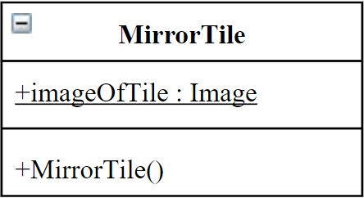
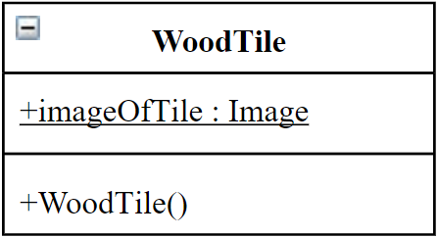
IMPLEMENTATION DETAILS

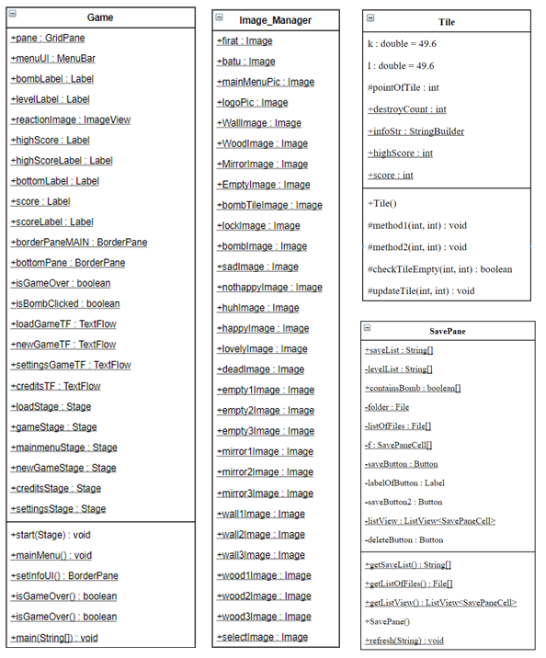
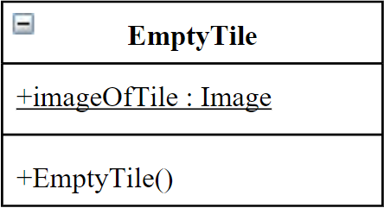
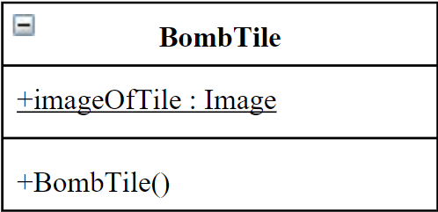
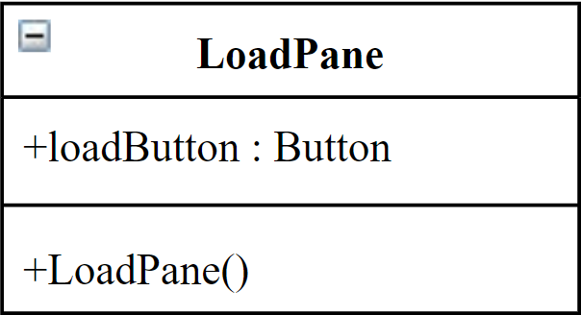
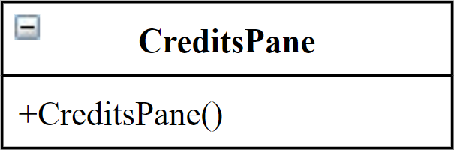
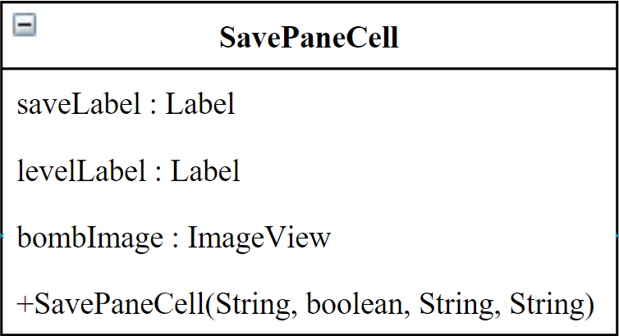
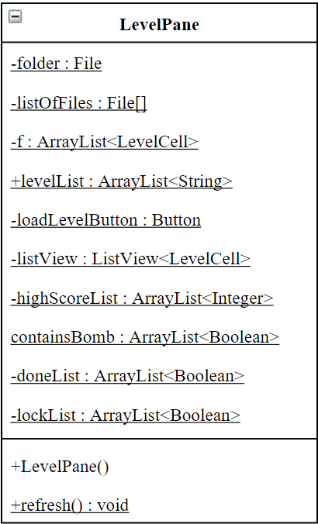
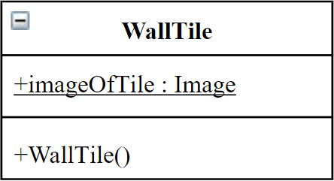
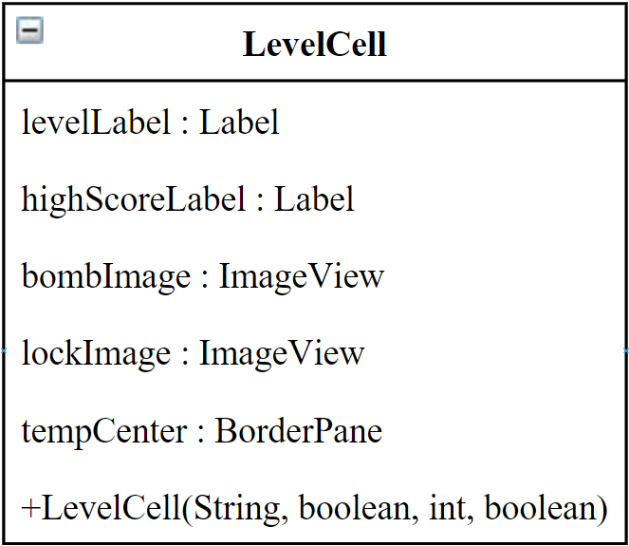
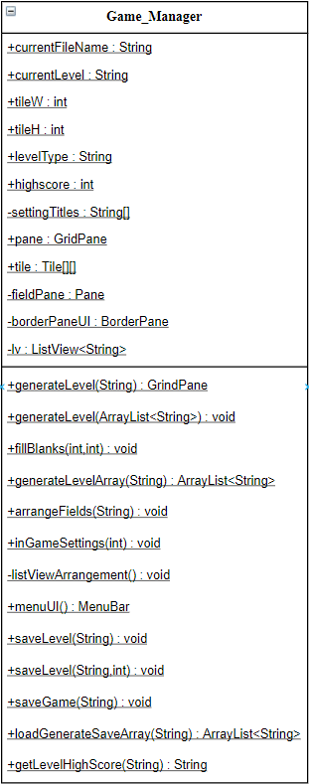
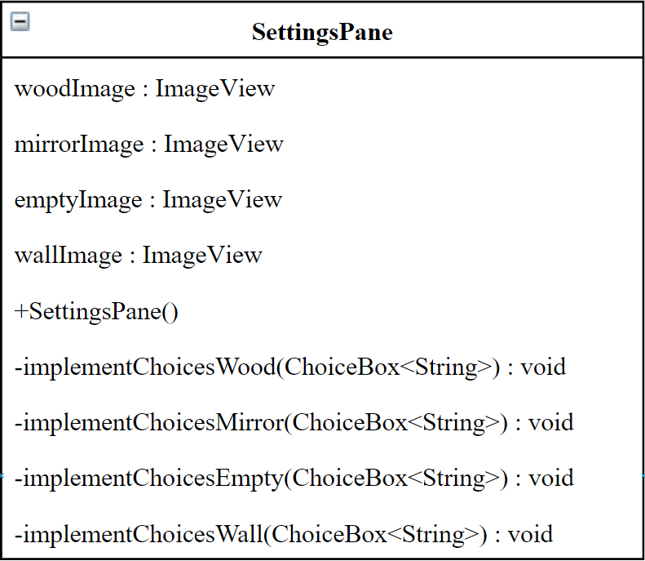

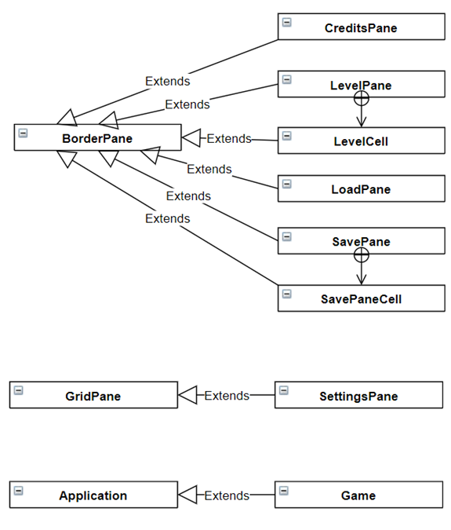

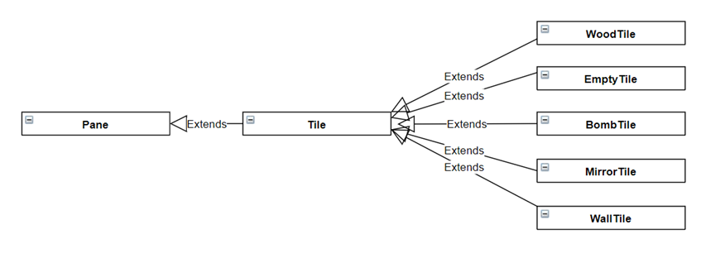

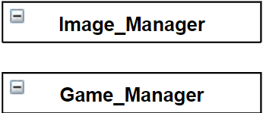

In this project, we have tried to keep organized by using separate classes with different usages. On this way, we’ve created such classes like Game Manager, separate Tile classes and separate Pane classes.
First of all, Game Manager class plays a big role on this project. The methods defined inside it nearly have used by all other classes. If we’d like to explain its general purposes:
- Holds the array of boxes and updates its column and width by the generated level’s width and height.
- Generate levels (constructs game pane).
- Creates in-game settings and its options.
- Creates Menu Bar and constructs it.
- Saves the current level to a new file.
- Saves the current level with new high score.
- Loads the chosen level.
- Loads the chosen save file.
- Gets the high score from the chosen level file.
The main class Game which contains main method has these purposes:
- Creates Main Menu when game opened.
- Constructs information interface that contains level, level type, score and high score.
- Checks if game is over.
- Arranges the main game screen’s layout.
The abstract Tile class that the other tiles(boxes) inherits from it:
- Keeps mouse click events under control when boxes clicked.
- Updates destroyed boxes with its points.
- Updates the bottom label of pane with the destroyed boxes.
- Updates the reaction image with the count of destroyed boxes

Panes that can be opened in main menu screen and in-game settings:
- Level Pane
- Lists the levels in the chosen folder.
- Loads the chosen level.
- Updates the game layouts width and height.
- Shows if levels have bombs or not.
- Shows if levels are locked or not.
- Shows levels high score.
- Load Pane
- Loads the chosen save file.
- Updates the game layouts width and height.
- Shows if save files level type has bombs or not.
- Updates score when loads.
- Save Pane
- Saves the current game with the given name
- Deletes the chosen file
- Shows if save files level type has bombs or not.
- Saves the current score.
- Settings Pane
- Changes the boxes textures.
- Credits Pane
- Shows credits of us.

Finally, Image Manager that holds all images in one class.

